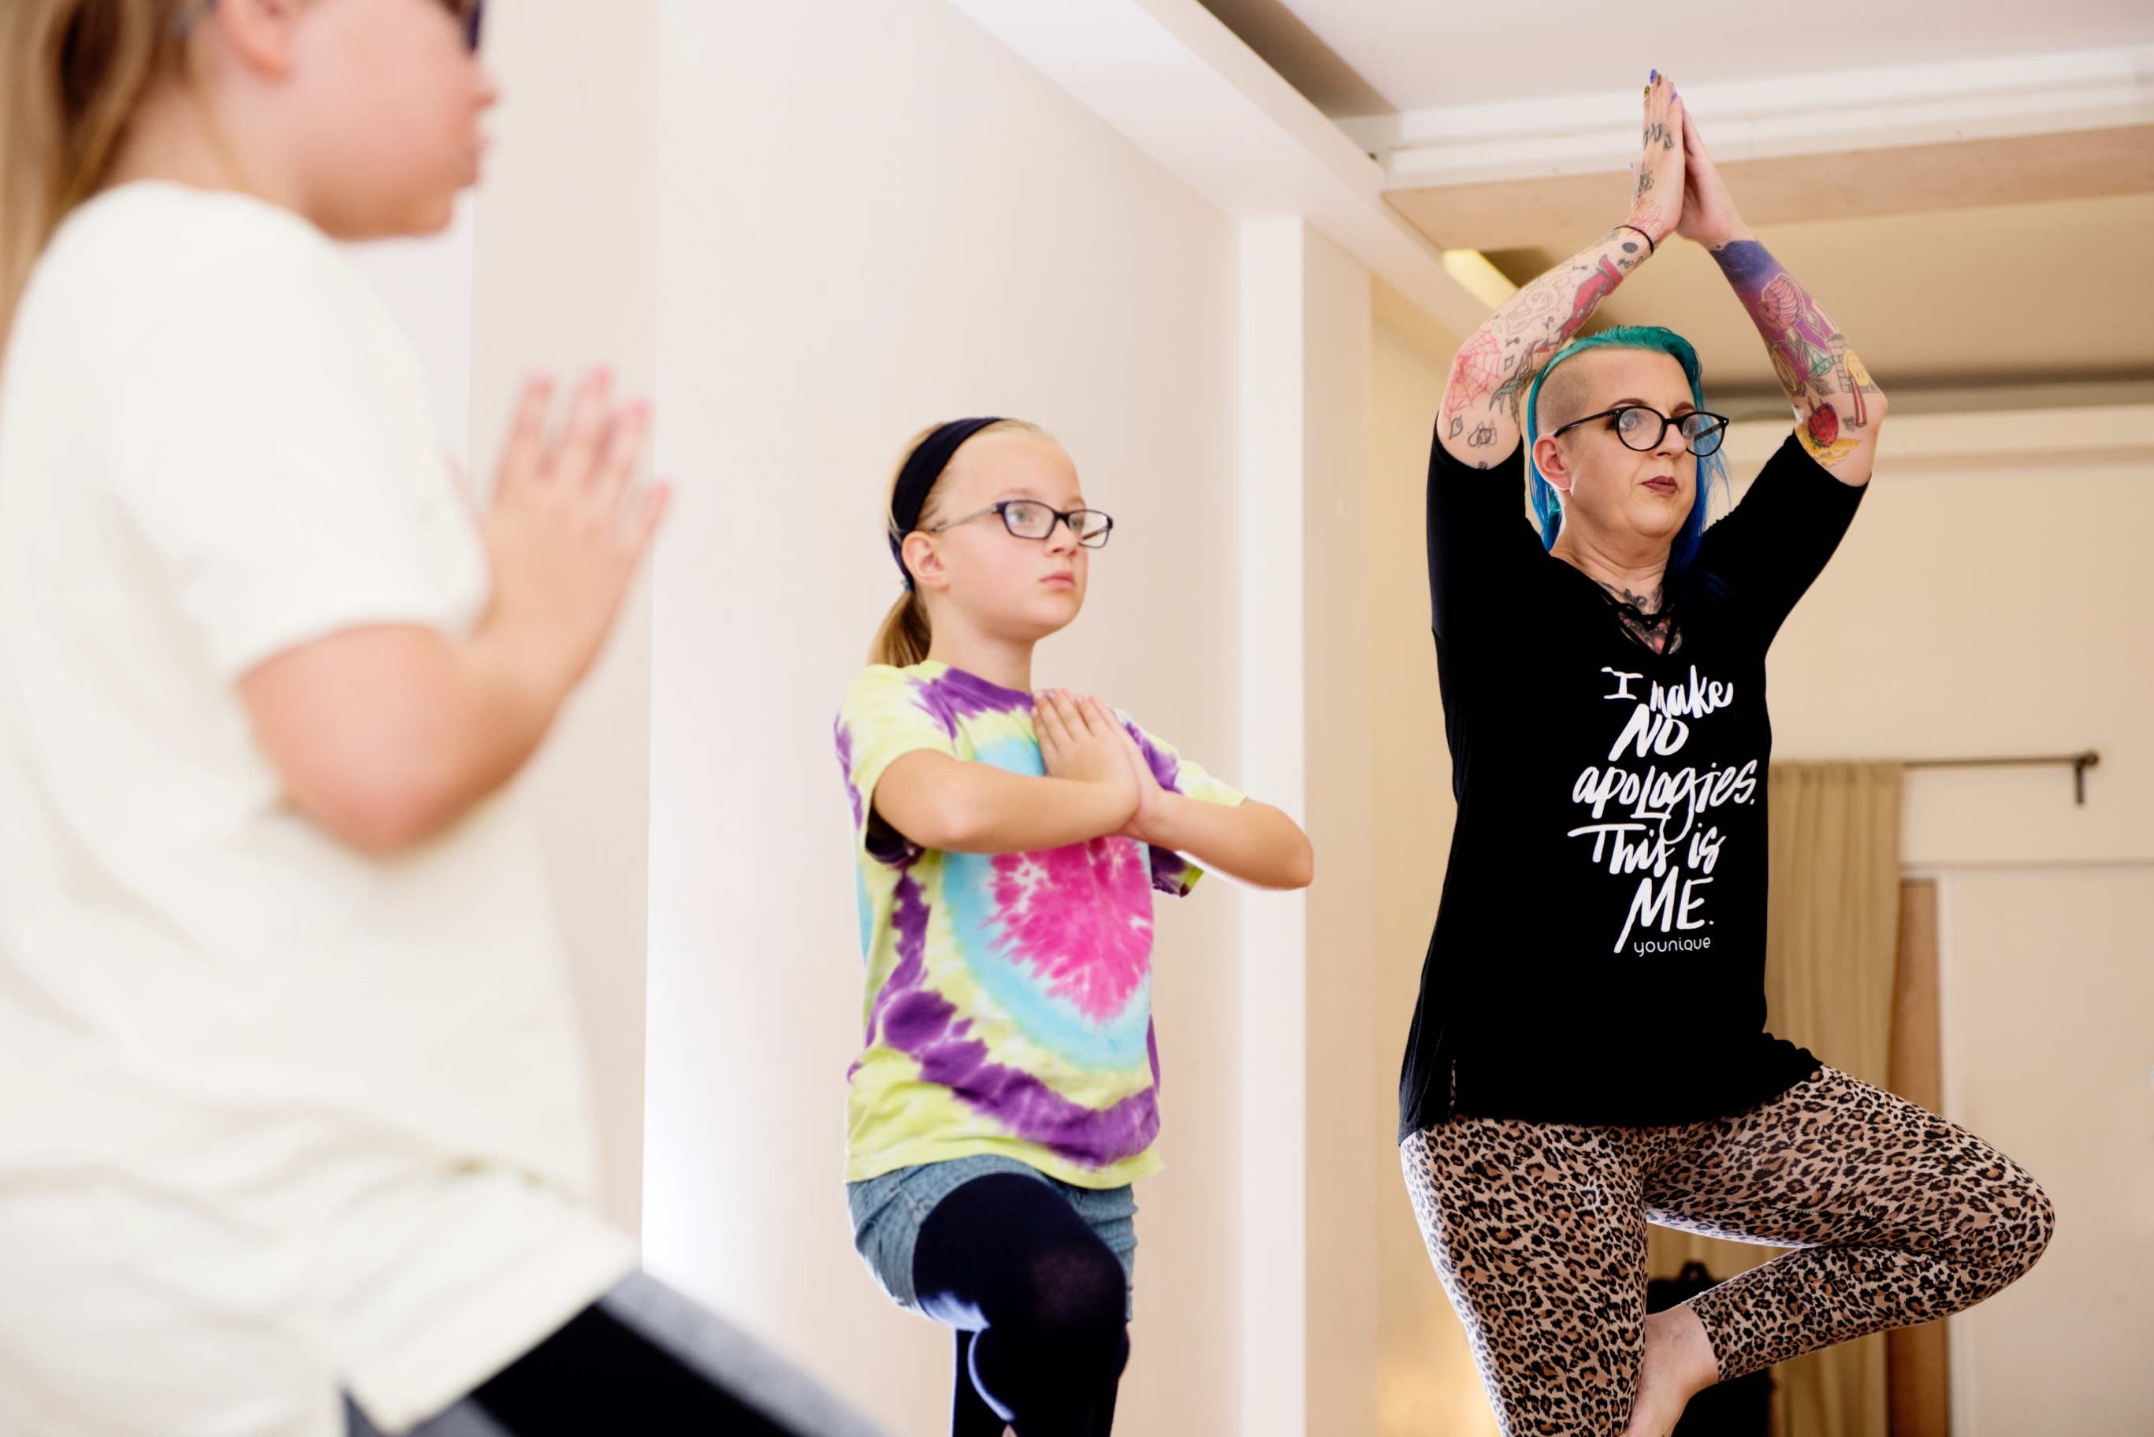

and Mindfulness

**Parents and children are invited to these gentle and fun yoga and mindfulness sessions, which are designed for parents and children to do together. They are aimed at children aged 2-12 years and suit all needs, interests and abilities.**

Through storytelling, puppetry and games, you and your child will be taken on a variety of adventures that incorporate yoga poses, breathing exercises, mindfulness and relaxation techniques to help stretch bodies, minds and imaginations!

The classes will stimulate, inspire and motivate both you and your child, helping your child to take part, have fun, gain confidence and have a go … while giving space for child and parent to share, explore and bond together.

Classes run at The Wild Goose Space, The Yard, Mina Road, St Werburghs, from 4 – 5pm on Thursdays – **term time only**. Free parking available on nearby streets. If you would like to book a place, try a class for £7 or talk more about the classes,

call Claire-Louise on 07949399633 or www.mindfullives.org.

**Family Yoga Class**

Time: 4pm – 5pm

Day: Thursdays (Term time only)

Cost: £30 for 5 week block (per parent/child pair and £15 per additional sibling for the block)

Place: The Wild Goose Space, The Yard, Mina Road, St Werburghs – Free Parking

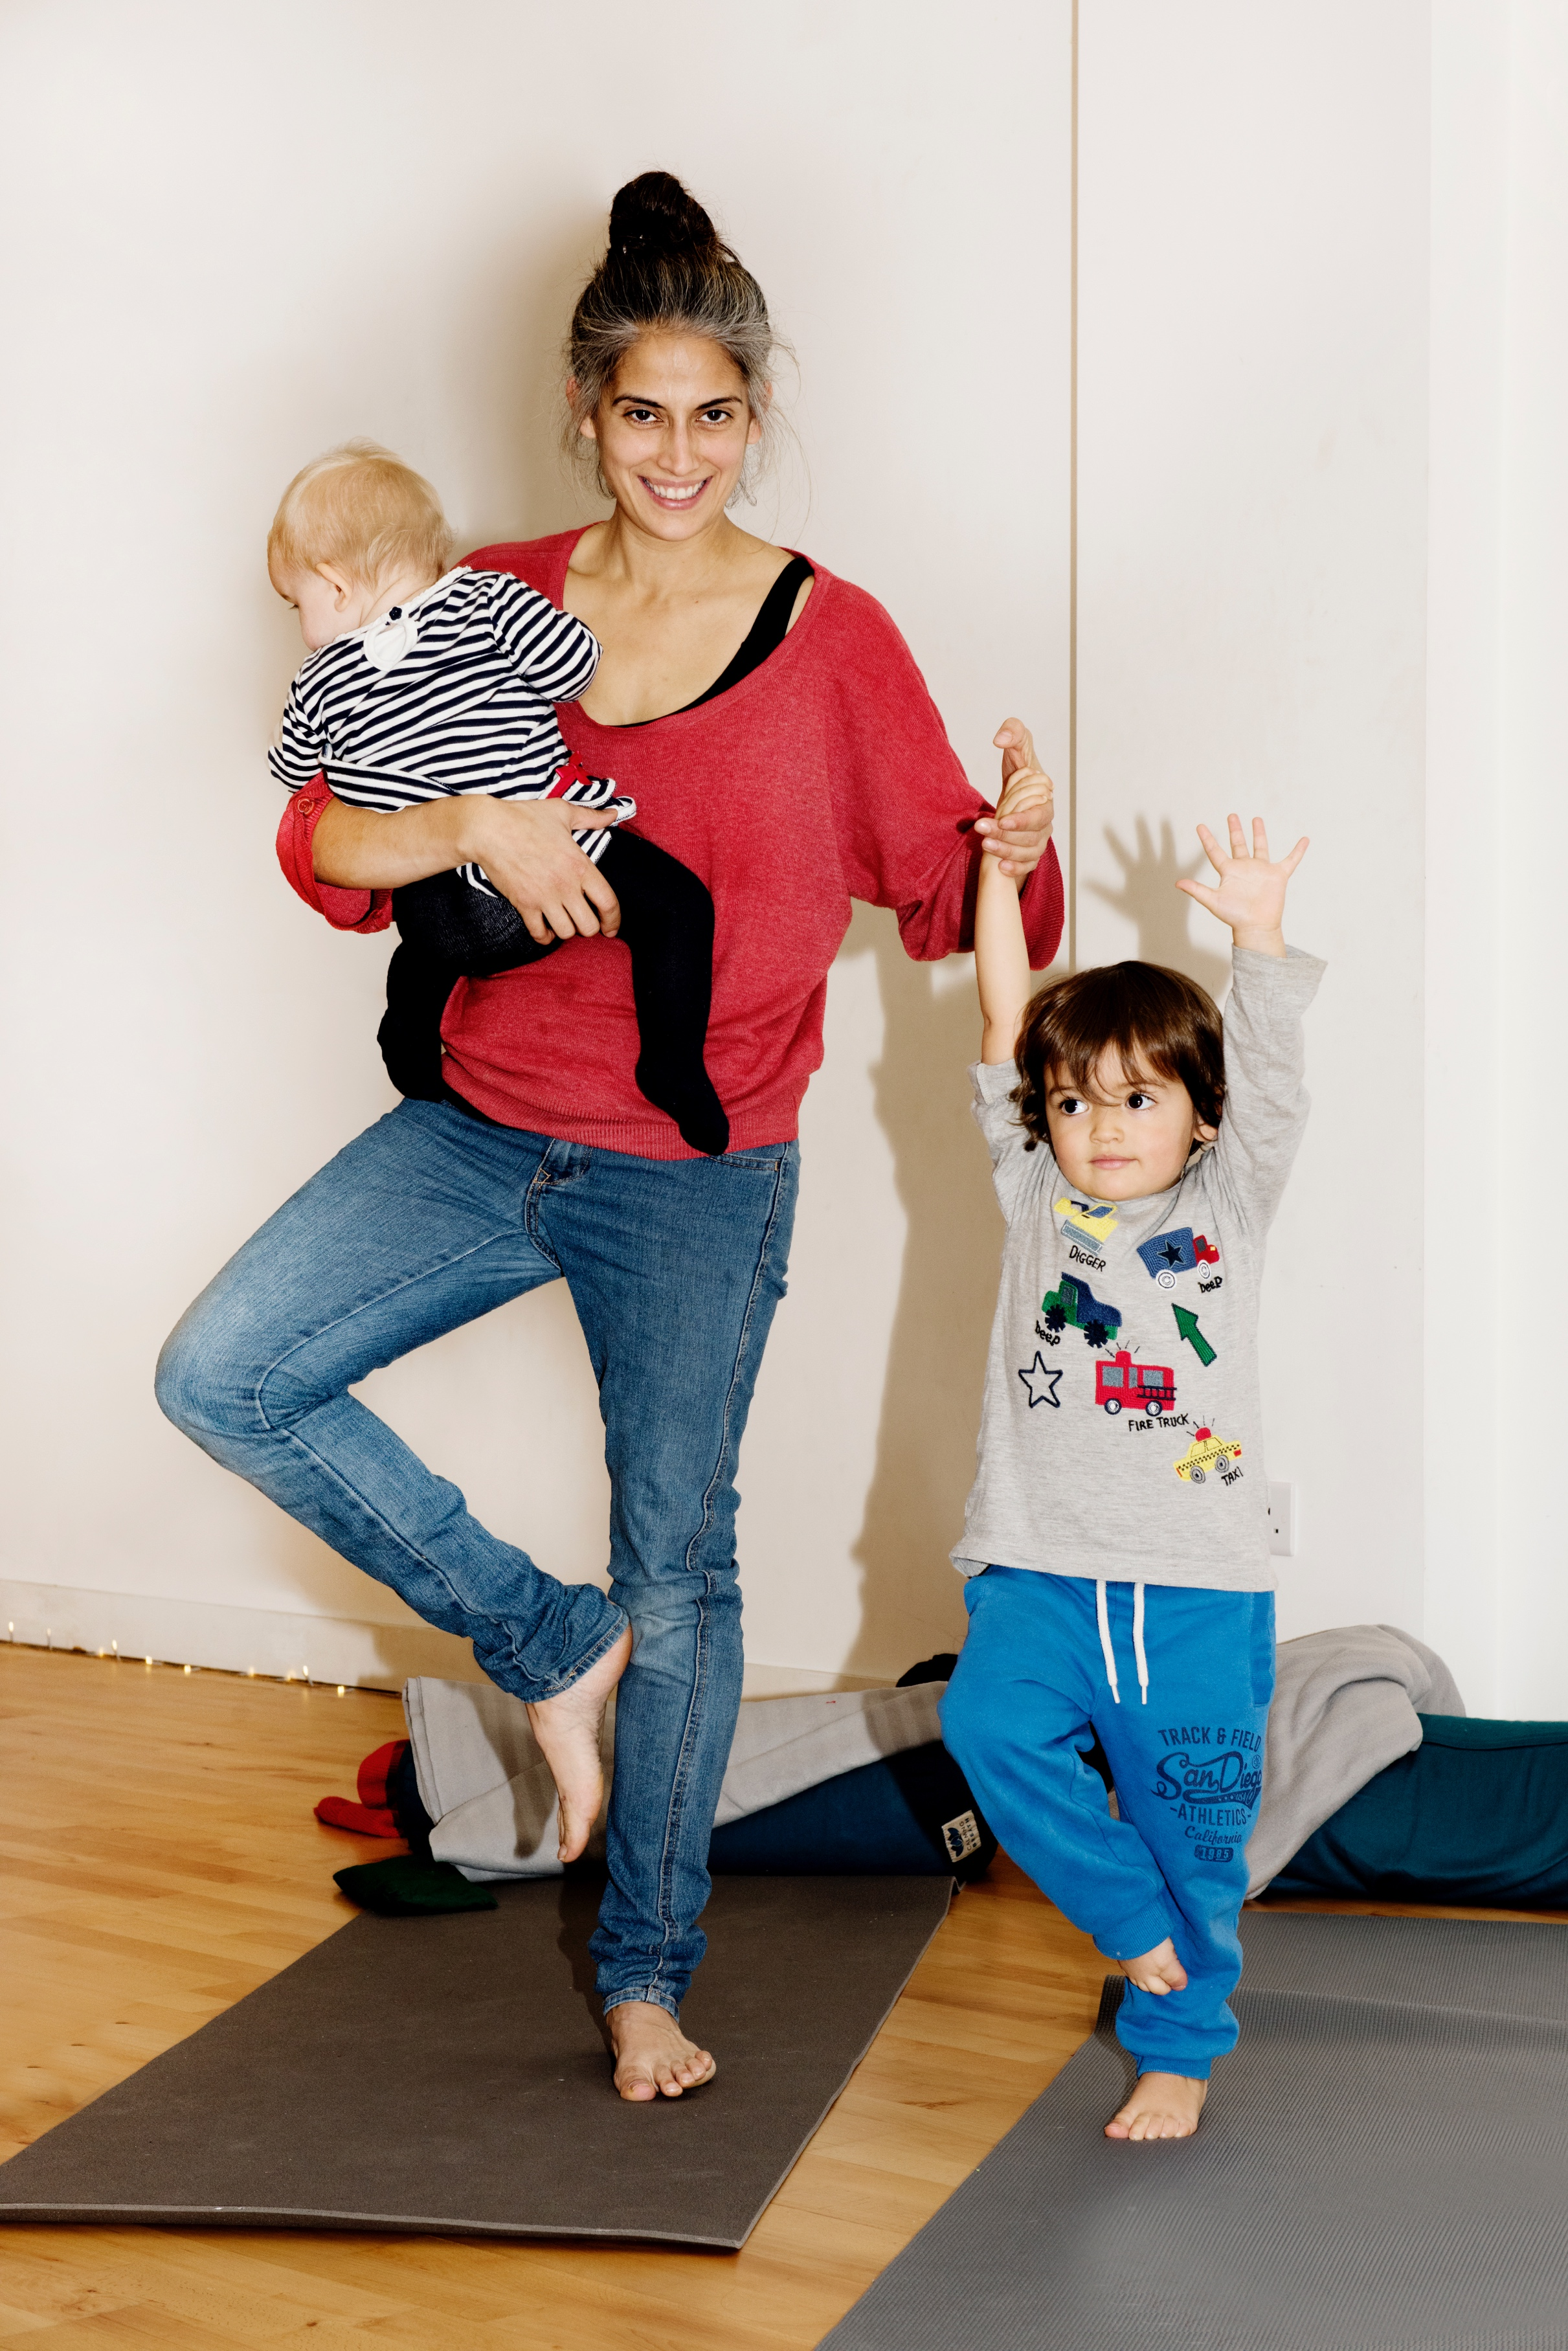

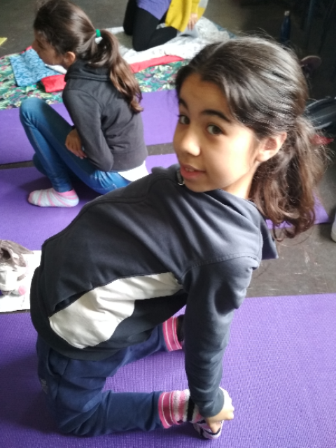

Family Yoga **thildYoga**